**Exercise 7.5**

Data set books contains the daily sales of paperback and hardcover books at the same store. The task is to forecast the next four days’ sales for paperback and hardcover books.

1. Plot the series and discuss the main features of the data.

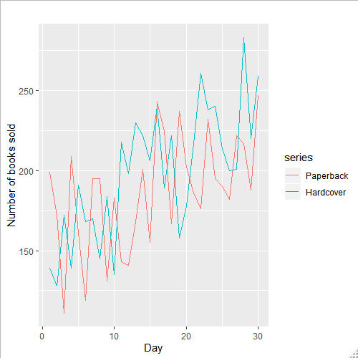

Sales of both paperback and hardback are both linear. They have an upward trend and heavy fluctuations from day to day

1. Use the ses() function to forecast each series, and plot the forecasts.

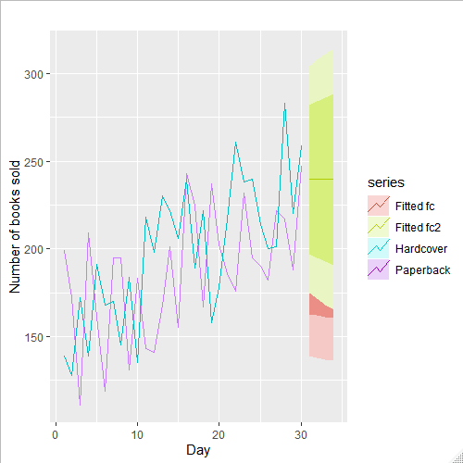

1. Compute the RMSE values for the training data in each case.

The RMSE for the paperback forecast is 33.64

The RMSE for hardback forecast is 31.93

**Exercise 7.6**

1. Now apply Holt’s linear method to the paperback and hardback series and compute four-day forecasts in each case.

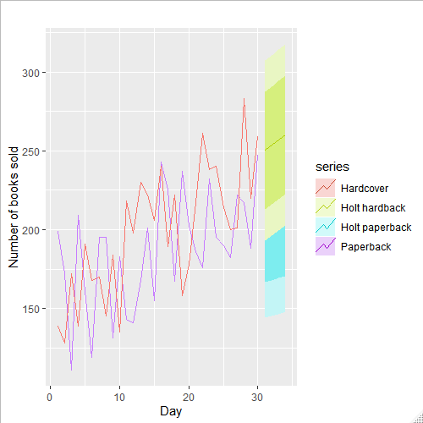

1. Compare the RMSE measures of Holt’s method for the two series to those of simple exponential smoothing in the previous question. (Remember that Holt’s method is using one more parameter than SES.) Discuss the merits of the two forecasting methods for these data sets.

The RMSE for holt paperback forecast is 31.14 compared to the SES paperback forecast of 33.64

The RMSE for holt hardback forecast is 27.19 compared to the SES hardback forecast of 31.93

Holts forecasting method has a smaller RMSE meaning that the forecast is more accurate than the SES method of forecasting

1. Compare the forecasts for the two series using both methods. Which do you think is best?

As in the previous answer holts method seem to be more accurate. In the SES graph the forecast smooths out whereas the holts forecast continues the upward trend

1. Calculate a 95% prediction interval for the first forecast for each series, using the RMSE values and assuming normal errors. Compare your intervals with those produced using ses and holt.

The RMSE for the prediction was 32.43 and 33.64 on the training set for SES on paperback

The RMSE for the prediction was 28.11 and 31.93 on the training set for SES hardback

The RMSE for the prediction was 32.86 and 31.14 on the training set for Holt paperback

The RMSE for the prediction was 30.18 and 27.19 on the training set for Holt hardback